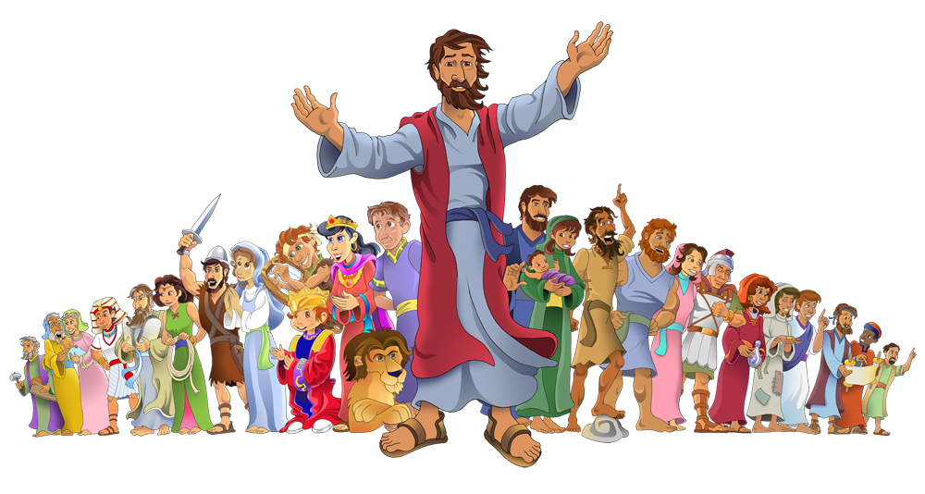
LESSONS FROM
the Little People

By John Kilgore and Scott Kercheville Name:_______________________
Schedule of Classes
Please read the given text and use the given sheet to prepare before class.

1. Hagar (Genesis 16, 21) -- God expects submission even in strife; yet, God is faithful in our desperation - even toward the little people.

2. Korah (Numbers 16) -- Ingratitude and grumblings against leadership spreads like bacteria and corrupts many.

3. Micah and the Levite (Judges 17-18) -- No king and a seemingly innocent lack of knowledge can lead many to do “what is right in their own eyes.”
Class Topics

4. Jeroboam, a Man of God, and an Old Prophet (1 Kings 13) -- The word of the Lord can mercifully correct and keep us safe - if we take it seriously.

5. Jehoshaphat, Ahab, and Michaiah (1 Kings 22) -- Seeking our opinion in God’s word is useless; giving God's word to stubborn people is dangerous.

6. The Great Woman of Shunem (2 Samuel 25; 2 Kings 4:8-37) -- True greatness changes lives through peacemaking, generosity, and contentment.

1 Prepare and participate. Bible classes can makes us more equipped, unified, and mature, but preparation and participation are needed. Without preparation, Bible class is quiet and comments are less focused and helpful. Without participation, we do not learn to speak truth in love.

Ephesians 4:11–15, “Now these are the gifts Christ gave to the church: the apostles, the prophets, the evangelists, and the pastors and teachers. Their responsibility is to equip God’s people to do his work and build up the church, the body of Christ. This will continue until we all come to such unity in our faith and knowledge of God’s Son that we will be mature in the Lord, measuring up to the full and complete standard of Christ. Then we will no longer be immature like children. We won’t be tossed and blown about by every wind of new teaching. We will not be influenced when people try to trick us with lies so clever they sound like the truth. Instead, we will speak the truth in love, growing in every way more and more like Christ, who is the head of his body, the church.”

2 Be concise. Take time to clearly share what you discover in the Bible, but allow time for others to share too. Self-awareness is needed. If you are the only one speaking or are speaking for minutes each time, pursue conciseness. Share, but try not to dominate the class.

Proverbs 18:2, “A fool takes no pleasure in understanding, but only in expressing his opinion.”

3 Be thoughtful with your words. Speak with humility, not anger. Avoid regurgitating what you have always heard. We can often speak in “Christianese” — using words that only mature Christians understand. Learn to speak the truth in love by using kind and understandable words that will help people grow. Consider if your words will build up or if they will confuse and hurt.
Rules for the Road

Ephesians 4:29, “Do not let any unwholesome talk come out of your mouths, but only what is helpful for building others up according to their needs, that it may benefit those who listen.”

4 Rely on the scriptures for truth. It is easy to rely upon worldly wisdom as truth. Bible study is about seeking God’s answers for our lives, not dispensing the advice of the world.

1 Corinthians 1:25, “For the foolishness of God is wiser than human wisdom, and the weakness of God is stronger than human strength.”

5. Attain unity in faith with patience. We can disagree about opinions, so we should be patient when we disagree (Romans 14). That being said, a purpose of Bible class is to attain to the unity of the faith. Truth is not relative, so we should seek definite truth and unity in faith when possible.

Ephesians 4:1–6, “… walk in a manner worthy of the calling to which you have been called, with all humility and gentleness, with patience, bearing with one another in love, eager to maintain the unity of the Spirit in the bond of peace. There is one body and one Spirit—just as you were called to the one hope that belongs to your call— one Lord, one faith, one baptism, one God and Father of all, who is over all and through all and in all.”

Note: Abram and Sarai in the Biblical text = Abraham and Sarah in this lesson

FYI The Bible background for the significance of Hagar goes back at least a decade to the LORD’s calling of Abraham to leave Ur of the Chaldees. Genesis 12:1-3,
“Now the Lord said to Abram, ‘Go forth from your country, and from your relatives and from your father's house, to the land which I will show you; 2 And I will make you a great nation, and I will bless you, and make your name great; and so you shall be a blessing; 3 And I will bless those who bless you, and the one who curses you I will curse. And in you all the families of the earth will be blessed.’" NASU

Abraham believed the LORD and obeyed not knowing where the new place would be and knowing that at this time he was childless. The LORD led him to Canaan and Abraham, at 75 years of age, began a new life as a foreigner in a strange land moving from place to place (Hebrews 11:8-10). Soon there was a famine and the whole family had to migrate to Egypt for survival. Presumably this is where the Egyptian slave, Hagar (possibly meaning flight), became Sarah’s handmaid. Likely, either Abraham bought her or possibly Pharaoh gave her to Sarah.

While in Egypt the LORD blessed Abraham and he was able to return to Canaan a much richer man. But his nephew Lot also had large herds and flocks and the land could not support both of them. This produced strife between the herdsman of Abraham and Lot. Abraham proposed that for peace they split up and gave Lot the first choice of the land. Lot chose the best land for himself which was down toward Sodom which at that time was very green and well-watered. The LORD then appeared to Abraham again and reaffirmed His promise to make of him a great nation. (Genesis 13:14-17) Abraham moved south from Bethel to Hebron (Genesis 13:18). (see Map). Hebron is where our first Hagar episode occurs.
#1: Hagar (Genesis 16, 21; Galatians 4:21-31)

Next, there was war in the land and nephew Lot was taken captive. Abraham rescued him and returned the people and the treasure that had been captured to the king of Sodom. Abraham had vowed to the LORD not to prosper from another’s wealth but only from the hand of the LORD (Genesis 14). Again the LORD appeared to Abraham, but Abraham was ready with a question:

Genesis 15:1-7
After these things the word of the Lord came to Abram in a vision, saying, "Do not fear, Abram, I am a shield to you; your reward shall be very great."
2 Abram said, "O Lord God, what will You give me, since I am childless, and the heir of my house is Eliezer of Damascus?" 3 And Abram said, "Since You have given no offspring to me, one born in my house is my heir." 4 Then behold, the word of the Lord came to him, saying, "This man will not be your heir; but one who will come forth from your own body, he shall be your heir." 5 And He took him outside and said, "Now look toward the heavens, and count the stars, if you are able to count them." And He said to him, "So shall your descendants be." 6 Then he believed in the Lord; and He reckoned it to him as righteousness. NASU
Episode 1 - Sarah, Abraham and Hagar
Read Genesis 16:1-15
- What do Sarah and Abraham demonstrate in their decision to use Hagar to fulfill God’s promise for a son? What is their apparent reasoning? What would have been the better course?

- After Hagar is pregnant, what does she demonstrate in her attitude toward Sarah? Why?

- What is Hagar’s attitude after the angel of the LORD spoke to her. What changed her?

- What does the LORD demonstrate about Himself and relatively insignificant people like Hagar?

- What is the lesson or lessons for us?

Episode 2 – Hagar and Ishmael versus Sarah and Isaac

FYI: After 25 years of waiting the LORD fulfills His promise to Abraham (100 years old) and Sarah (90 years old). Isaac (laughter) is born.

Read Genesis 21:1-21; 25:12-18
- Why was it important to make absolutely certain as to who was the rightful heir of Abraham?

- What apparently enables Abraham to drive out Hagar and Ishmael?

- Why does God rescue Hagar and Ishmael?

- What is the lesson or lessons for us?

Epilog – Salvation by Keeping the Law or Obedient Faith

FYI: Paul writes to the Galatian churches because he is alarm that they are so quickly leaving Christ for a different and false gospel. Jewish Christians have come in and taught the Gentile Christians that in addition to obedience to Christ one must keep the Law and be circumcised like a Jew in order to be saved. It is the classic struggle between salvation by works (the merit we earn by what we do) and salvation by faith (trusting in the promise of God). Paul denies their assertion and brands them as false teachers who are anathema to the Lord. Paul uses an allegory (extended metaphor usually in story form) where the key characters are Hagar and Ishmael, Sarah and Isaac. Hagar and Ishmael represent slavery that follows from trusting in our own meritorious works of the Law. Sarah and Isaac represent freedom that follows from trusting in Christ. Paul then draws this conclusion:

Galatians 4:28-31
And you brethren, like Isaac, are children of promise. 29 But as at that time he who was born according to the flesh persecuted him who was born according to the Spirit, so it is now also. 30 But what does the Scripture say? “Cast out the bondwoman and her son, for the son of the bondwoman shall not be an heir with the son of the free woman.” 31 So then, brethren, we are not children of a bondwoman, but of the free woman. NASU

Read Galatians 4:21-31
- In what are we enslaved if we are children of the flesh and of the bondwoman, Hagar?

- How are we free if we are children of promise and of the free woman, Sarah?

- From Hagar what can we learn about God?

- What can we learn about ourselves?

- If you knew that in future generations God would use even your bad choices and sins to encourage others for good, how would this make you feel? Does God do this?

The Places of Hagar:
- Oaks of Mamre, Hebron – Hagar is not mentioned here but this is where she apparently lived with Abraham and Sarah when she enters the Genesis narrative. Genesis 13:18 NASU
- Wilderness of Shur – “Now the angel of the Lord found her by a spring of water in the wilderness, by the spring on the way to Shur.” Genesis 16:7 NASU
- Beer-lahai-roi – “Therefore the well was called Beer-lahai-roi, behold, it is between Kadesh and Bered.” Genesis 16:14 NASU
- Wilderness of Paran – “God was with the lad, and he grew; and he lived in the wilderness and became an archer. 21 He lived in the, wilderness of Paran, and his mother took a wife for him from the land of Egypt.” Genesis 21:20-21 NASU

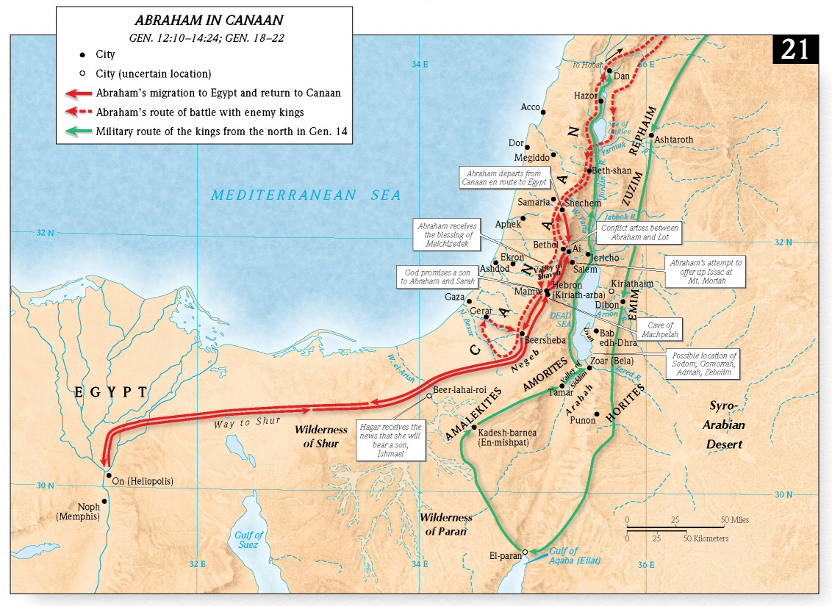

FYI – Korah was a Levite who led a revolt against the leadership of Moses and Aaron. Korah in concert with others wanted the power of leadership for themselves. Korah was the son of Izhar, the brother of Amram, the father of Moses and Aaron, making him a cousin to them. (Exodus 6:16-21; Numbers 16:1) All of the priests were chosen from the tribe of Levi through Aaron who was chosen as the first High Priest. Levites through descendants other than Aaron were given Tabernacle/Temple maintenance tasks.

Korah was probably influenced by jealousy because the high honors and privileges of the priesthood had been denied him. Moses was the leader through whom the LORD spoke and he along with his brother Aaron exercised power over the whole nation. This was resented by Korah and others like Dathan and Abiram who along with 250 tribal leaders challenged the leadership of Moses and Aaron.

In the New Testament, Jude used Korah as an example of a rebellious person who denies our only Master and Lord, Jesus Christ. Therefore Christians should not follow such men and even oppose them.
#2: Korah (Numbers 16; Jude 11)

Read Numbers 16
1. What reasoning did Korah and the rebels give for why they should have greater leadership? Vs. 3

2. When people try to wrest authority from a constituted power, what often is the rationale?

3. What was Moses’ first reaction? What did it indicate? Vs. 4

4. What did Moses propose as a remedy to the situation? Vss. 5-7

5. What is the argument that Moses makes to Korah and the other rebels? What does this show about the attitude of Korah and his companions? Vss. 8-10

6. Who does Moses say the rebels are really rebelling against? Why? Vs. 11

7. What is the specific grievance of Dathan and Abiram? Vss. 12-14

8. What was Moses’ reaction and his statement to the LORD? What does it mean? Vs. 15
FYI – Firepans and censers were used in the Tabernacle/Temple worship to transport burning coals, trimmed wicks, and to burn incense. In the Temple worship, the use of the censer and the right to burn incense were jealously guarded prerogatives of the priests, the sons of Aaron. It was dangerous for any other unauthorized person to do it. Example: When Uzziah (or Azariah), king of Judah, unlawfully entered the Temple of the Lord and presumed to take a censer in his hand and burn incense on the altar, he was stricken with leprosy as punishment (2 Chronicles 26:16-23). The censer was used in the purification ritual on the Day of Atonement (Leviticus 16:12-14).

9. How was the dispute settled? Vss. 16-35 (Note vss. 28-30)

10. What was done with the censers? Why? Vss. 36-40

11. What was the reaction of the congregation of Israel? Why? Vss. 41-42

12. What was the LORD’s reaction? Vss. 43-45

13. What did Moses and Aaron do? With what result? Vss. 46-50

14. Name some Bible authorized leadership/authority. Why is it important to submit to such leadership?

15. What are ways of rebelling against the LORD’s leaders?

16. What attitudes and actions are needed in order to submit to God’s leaders?

1. Read Judges 17-18. Briefly summarize the account in your own words.

2. The text contains a couple of teaching statements which tell us what is wrong here. What are they?

3. How did God warn Israel about this in Numbers 15:37-41 and Deuteronomy 12:1-14? What similar warnings does God give us in Matthew 5:19, 7:21-23, John 14:15, and Romans 10:1-3?

4. Comb through the text and find examples of this stated problem, “In those days there was no king in Israel. Everyone did what was right in his own eyes.” There are many examples!

5. Mark two examples from #4 which stand out to you the most. Show from Scripture what is wrong with what happened. How do you think they came to do/think these things with clear consciences?
#3: Micah and the Levite (Judges 17-18)

6. Bring the message to us today. How can we make similar mistakes? How can we prevent this?

7. Notice Judges 17:13. Even if everything Micah and the Levite were practicing was correct, what is wrong with Micah’s thoughts? How can we mistakenly think similarly? How can we prevent this?

8. Notice Judges 18:29-31 (see ESV/HCSB/NIV). Shockingly, who is this “priest?” How long did the idolatry and priesthood continue? How can we learn/make application from this information?

1. Read 1 Kings 12:25-13:34. Briefly summarize the account in your own words.

Jeroboam and the Word of the Lord (13:1-7, 31-34)
2. What was the word of the Lord to Jeroboam?

3. How did Jeroboam initially respond to the word of the Lord? Consider Revelation 3:19-22. How can we prevent responding like Jeroboam?

4. What signs did the Lord give to Jeroboam here? Why would God do this?

5. What was Jeroboam’s second reaction (13:6-7)? Despite this, what did Jeroboam eventually do (13:31-34)? See Matthew 21:28-32 also. How can we learn from this and prevent similar mistakes?

A Man of God and the Word of the Lord (13:7-32)
6. What was the word of the Lord to “the man of God” (13:7-10)?
#4: Jeroboam, a Man of God, and an Old Prophet (1 Kings 13)

7. How did the man of God initially treat the word of the Lord (13:7-17)?

8. Despite this (#7), what did the man of God do and what happened to him as a result (13:18-32)?

9. Consider the mistakes of this man of God. Consider also 2 Corinthians 11:1-4, Galatians 1:6-10, and 1 John 4:1-3. How can we learn from these passages and prevent this man’s mistakes?

An Old Prophet and the Word of the Lord (13:11-32)
10. Despite being a real prophet (cf. 1 Kings 13:11, 20-22, etc.), how does this old prophet treat the word of the Lord and his job? How can we make similar mistakes? How can we prevent this?
1. Read 1 Kings 22. Briefly summarize the account in your own words.

2. Consider Jehoshaphat. Where did he succeed? How can we learn from this and succeed similarly?

3. Where did Jehoshaphat fail? Consider also 1 Corinthians 15:33 and 2 Corinthians 6:14-7:1. How can we learn from these passages and avoid Jehoshaphat’s mistakes?

4. Consider Ahab. In what ways did he fail? How can we learn from Ahab and avoid similar failures?

5. According to Micaiah, what was happening before God’s throne and what was God seeking to do? Consider also 2 Thessalonians 2:9-12. Understanding how God worked here, how can we learn and make application in our own lives?
#5: Jehoshaphat, Ahab, and Michaiah (1 Kings 22)

6. Consider Ahab’s treatment of Micaiah (22:26-27). According to Jesus, how did the Pharisees and scribes foolishly read/apply passages like this in Matthew 23:29-36? How can we learn from this?

7. “Paint”/describe this scene from Micaiah’s vantage point. How would you feel in Micaiah’s shoes? What temptations would you face?

8. What situations do we face which put us in different, but similar circumstances?

9. How can we overcome these temptations (#7) and display the character of Micaiah? Consider also the messages of Matthew 5:10-16, 10:16-39, 19:27-30, John 15:18-24, and Revelation 6:9-11.

FYI: Our modern world has really changed the concept of feminine greatness. Women who do not put success in a career at the center of the stage are now looked down on. Even God's people have begun to believe that women who devote much of their time to serving their family, neighbors, and church are settling for far less than they can achieve. The issue is not whether a godly woman can work outside the home. We have several examples of such in Scripture. The question is, what truly defines feminine greatness? The unnamed Shunammite woman gives us insight into this issue as she portrays a truly great and prominent woman.
- "Next to God we are indebted to woman, first for life itself, and then for making it worth having." (Bovee)
- "Contact with a high-minded woman is good for any man." (Henry Vincent)
#6: The Great Woman of Shunem (2 Kings 4:8-37)
- Spiritual Perceptive | - Contented
- Hospitable | - Passionately Devoted
- "There are a few things that never go out of style, and a feminine woman is one of them." (Jobyna Ralston)
This lesson will present four marks of feminine greatness. They are:

Read 2 Kings 4:8-37

Spiritually Perceptive
- What did the Shunammite woman perceive about Elisha? How would she have reached this conclusion? Vss. 8-10

- What does it mean to be spiritually perceptive? How does one become spiritually perceptive?

Hospitable:
- Define hospitable.

- How does this woman demonstrate that she is hospitable? Vss. 8-10

- What is required in our world in order to be hospitable?

Contented:
- Define contentment.

- How does this woman demonstrate that she was contented? Vss. 11-13
- What does contentment enable you to do or to be? Philippians 4:10-13

- How do you learn to be content?

Passionately Devoted:
- To whom or what is this woman passionately devoted? Vss. 14-37

- List and explain the things that express her passionate devotion? Vss. 14-37

- What are the things and/or persons about which we are passionately devoted?

SHUNEM A town in the territory of Issachar (Josh 19:18), near Mount Gilboa. A Philistine army gathered at Shunem before the battle in which Saul was slain (1 Sam 28:4). Elisha lived for some time there and revived the son of the Shunammite woman (2 Kgs. 4:8–37). It was a small village in the Roman period. Eusebius (Onom. 158, 11–12) knew a place in his day by the name of Sulem, about 5 miles south of Mount Tabor. Identified with a small mound near the village of Solem.

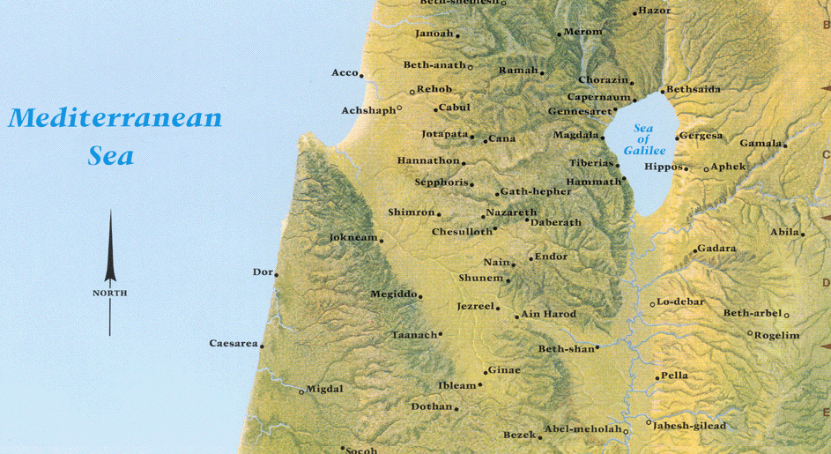

Taken and adapted from the New Unger's Bible Dictionary. Originally published by Moody Press of Chicago, Illinois. Copyright © 1988.
FIREPAN (Heb. maḥtâ, from ḥaṯâ, ‘to snatch up’). A bowl-shaped utensil with a handle used in connection with the tabernacle and Temple services for three different purposes. 1. In some passages it refers to the snuffdish made of gold, which held the pieces of burnt lamp-wick removed by the tongs or *snuffers (Ex. 25:38; 37:23; Nu. 4:9; 1 Ki. 7:50; 2 Ki. 25:15; 2 Ch. 4:22; Je. 52:19, the last four of these references being wrongly translated ‘censer’ and ‘firepan’ in av). 2. Elsewhere it refers to the bronze firepan which was used to carry coals away from the altar of burnt offering (Ex. 27:3; Nu. 4:14, the second of these references being wrongly translated ‘censer’ in av). 3. In other passages it is used of the *censer, also made of bronze, in which incense was burnt (Lv. 10:1; 16:12; Nu. 16:6, 17–18, 37 39, 46). Whitcomb, J. C. (1996). Firepan. In D. R. W. Wood, I. H. Marshall, A. R. Millard, J. I. Packer, & D. J. Wiseman (Eds.), New Bible dictionary (3rd ed., p. 369). Leicester, England; Downers Grove, IL: InterVarsity Press.
CENSER. In many rituals an *altar was specifically devoted to the burning of incense. Its form was usually either a bowl mounted on a pedestal, often conical in shape, i.e. ‘incense-altar’ (Heb. miqṭereṯ, lxx thymiatērion, 2 Ch. 26:19; Ezk. 8:11); so translate for censer (av) in Heb. 9:4 (B. F. Westcott, The Epistle to the Hebrews, 1903, pp. 248–250). libanotos is used in Rev. 8:3, 5. On the altar perfumes such as frankincense or cedar-pine were piled or thrown to create a sweet-smelling smoke (BASOR 132, 1953, p. 46). Small stone incense-altars with concave bowls on legs are commonly found, or depicted in ancient art, e.g. the horned altar from Megiddo. For illustrations, see ANEP, pp. 575–581, 626. Some censers were portable and made of bronze (maḥtâ, Lv. 10:1; 16:12; Nu. 16:6) or gold (1 Ki. 7:50), and used for carrying a few burning coals (so niv; av ‘censer’; rsv ‘firepan’). The ‘censer’ of Ezr. 1:9 (rsv, maḥlāp̱) may denote some other vessel (niv ‘silver dishes’; neb ‘of Various kinds’,; av ‘knife’,). Gooding, D. W., & Wiseman, D. J. (1996). Censer. In D. R. W. Wood, I. H. Marshall, A. R. Millard, & J. I. Packer (Eds.), New Bible dictionary (3rd ed., p. 179). Leicester, England; Downers Grove, IL: InterVarsity Press.
Nelson's Illustrated Bible Dictionary, Copyright © 1986, Thomas Nelson Publishers

